**Creating Networking Resources in Amazon Virtual Private Cloud**

Create VPC 2

Create Subnet 3

Create Route Table 4

Internet Gateway 6

Attach to VPC (Internet gateway attached to VPC) 7

Add route to route table and associate subnet to route table 8

Subnet Association 11

Security 12

Creating a Network ACL 12

Creating a Security Group 15

Launch Instance 15

# Create VPC

# Create Subnet

# Create Route Table

# Internet Gateway

## Attach to VPC (Internet gateway attached to VPC)

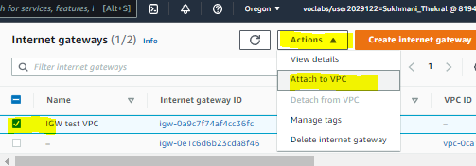

## Add route to route table and associate subnet to route table

## Subnet Association

# Security

## Creating a Network ACL

## Creating a Security Group

# Launch Instance



